CS 255 System Design Document Template

This template lays out all the different sections that you need to complete for Project Two. Each section has guidance to prompt your thinking. You will need to continually reference the interview transcript as you work to make sure that you are addressing your client’s needs. There is no required length for the final document. Instead the goal is to complete each section based on what your client’s needs are. Remove this note when you are finished, and replace all bracketed text with the relevant information.

UML Diagrams

UML Use Case Diagram
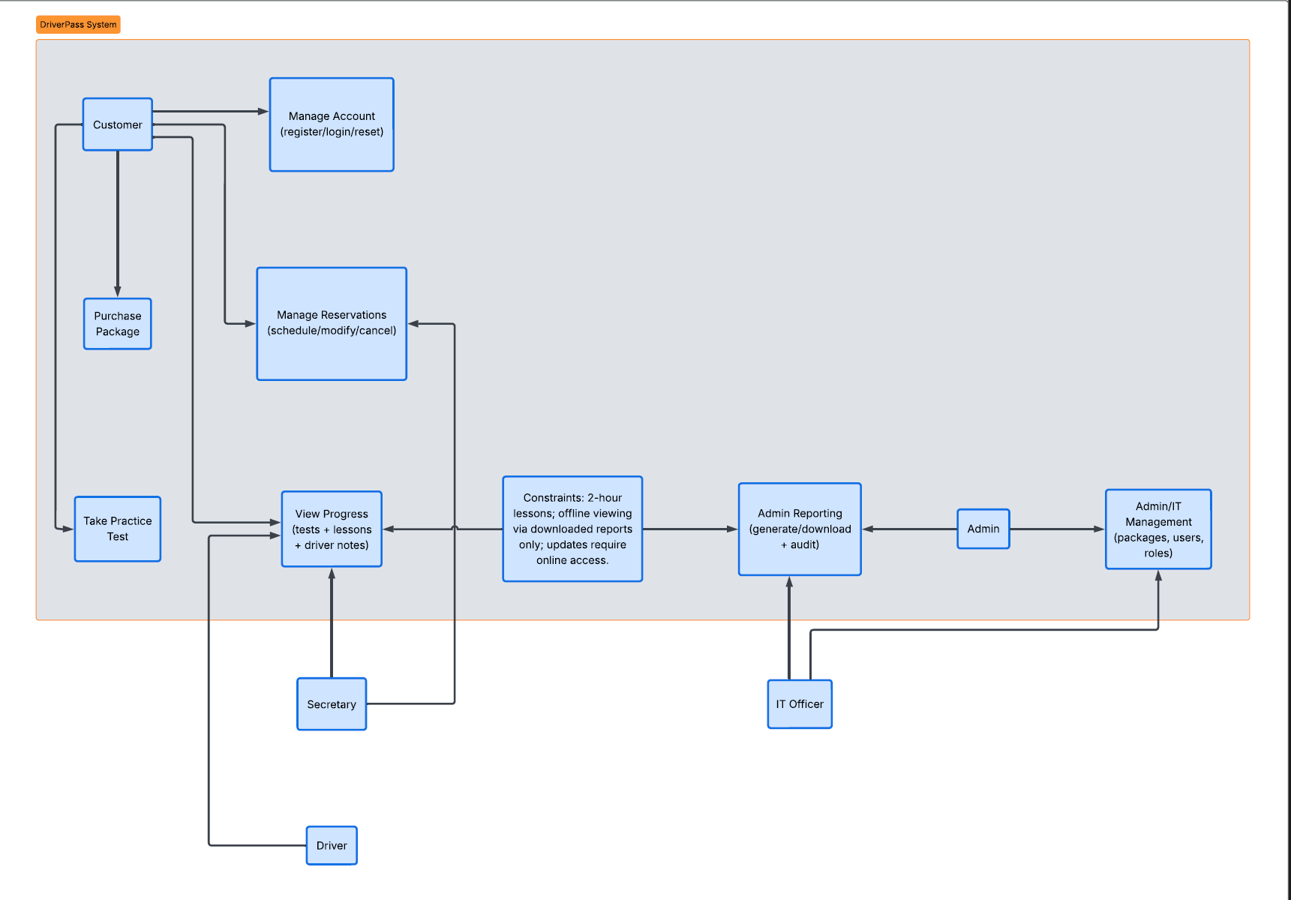

UML Activity Diagrams
Diagram 1: Schedule Driving appointment online:
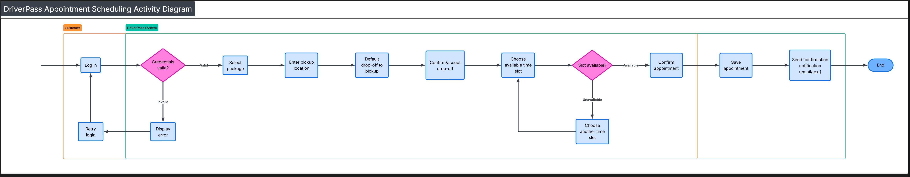
Diagram 2: Take Practice Test + Track progress
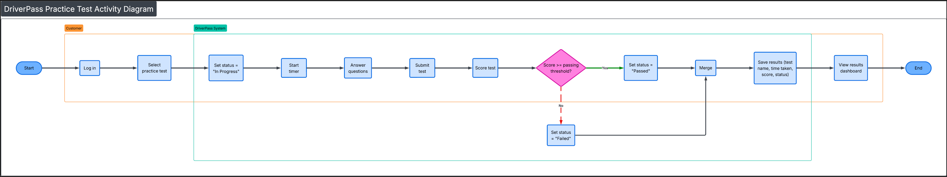

UML Sequence Diagram
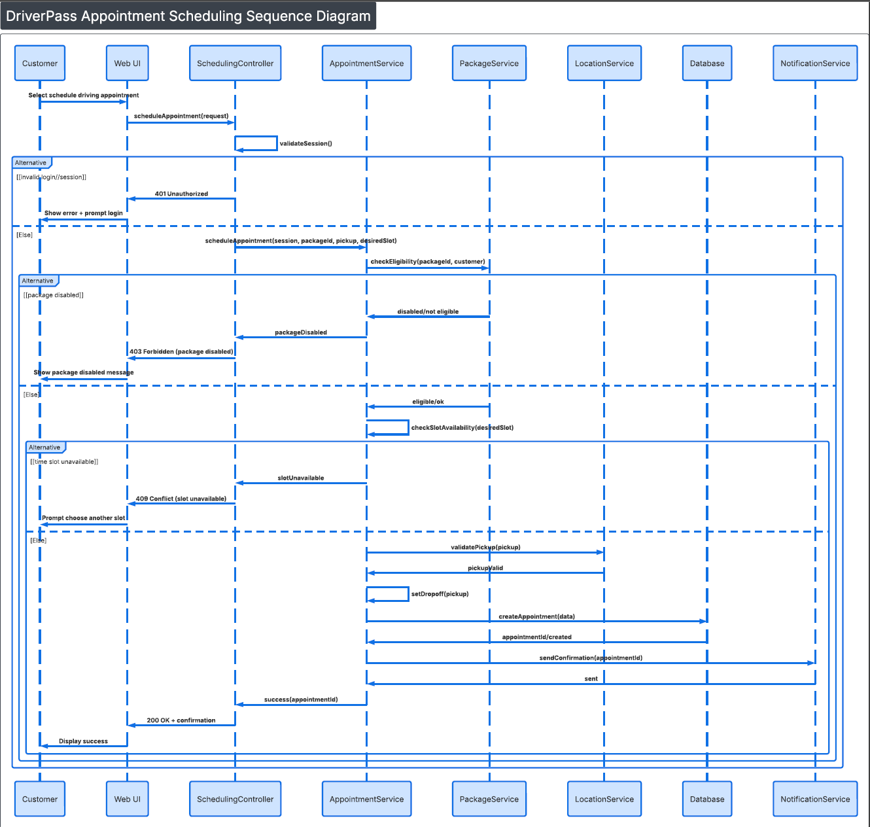

UML Class Diagram
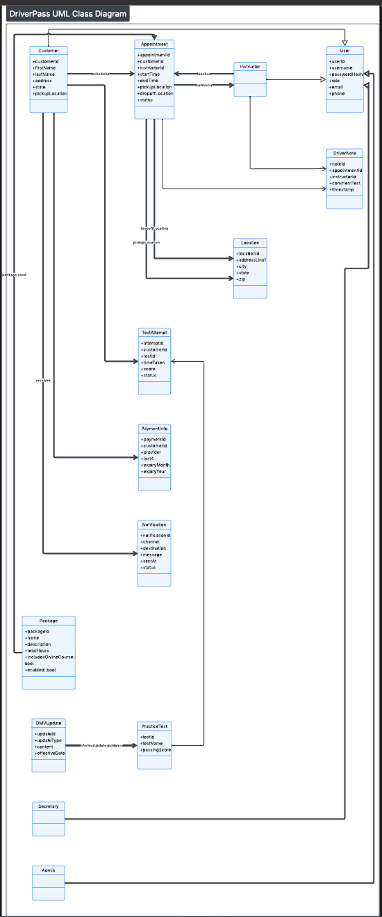

Technical Requirements
Hardware
- Cloud-hosted web application (no physical servers required for DriverPass).
- Staff devices: modern Windows/macOS PCs with a current web browser for secretary/admin work.
- Customer devices: mobile/desktop web access.
- Optional: tablets/laptops for instructors to view schedules and add driver notes.
Software
- Web application hosted in a cloud environment (per client request to minimize local IT burden).
- Secure authentication with password reset capability.
- Database for storing customers, packages, appointments, test attempts/results, and driver notes.
- Integration point (API or feed) for DMV updates so DriverPass can receive rule/policy/question changes and trigger notifications.
Tools
- Web UI framework (client-facing + internal admin/staff portal).
- Notification tooling (email/SMS provider) for appointment confirmations and DMV update alerts.
- Role-based access control (RBAC) so admin/secretary/instructor/customer capabilities are separated.
- Logging/monitoring to support troubleshooting and basic auditing (especially for scheduling changes and account actions).
Infrastructure
- HTTPS for all traffic (encrypted communication).
- Cloud backups and disaster recovery handled by the hosting provider (matches “we do not want to deal with backup/security”).
- Access control and least privilege (customers can only see their own info; staff can see customer scheduling; admin controls system settings/packages).
- Scalability: support multiple concurrent customers taking practice tests and scheduling appointments.

